STEPS FOR SUBMISSION OF REPORTS IN VIVA PORTAL
1. Steps for Submitting Abstract / Outline Report

Please log in to the E-Learn portal at https://elearn.bits-pilani.ac.in/ using your BITS E-Learn Mail ID and password.



After logging into the eLearn portal, click the “My Academics” section located at the left of the homepage.
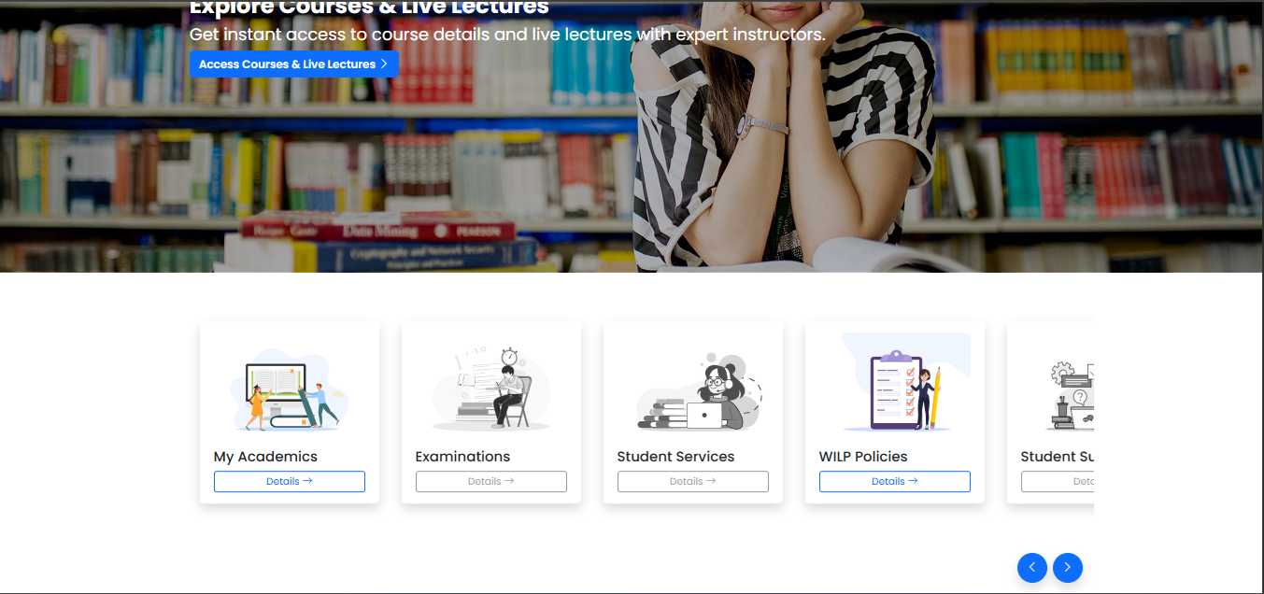
After clicking on My Academics, click the “Viva / Project” section



Then click on Go To VIVA/Project Portal
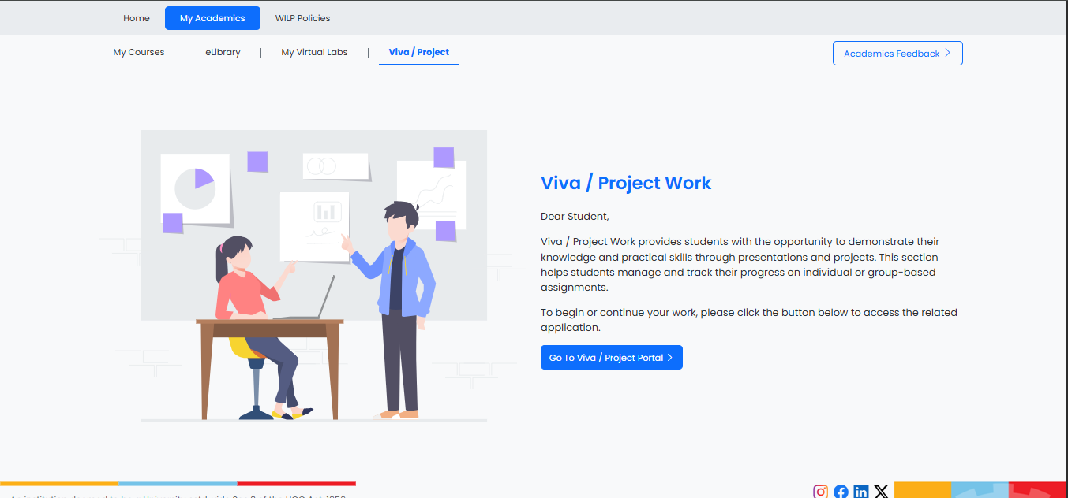

Then you will get redirected to the VIVA portal homepage.
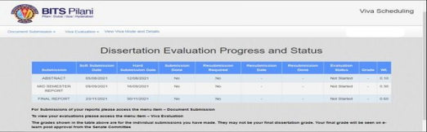

Click on the “Document Submission” link at the top left of the screen to make a selection from the dropdown menu.
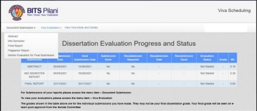

Please click on the “Abstract” option in the dropdown menu to view or upload the Abstract/Outline document on the Viva Portal.

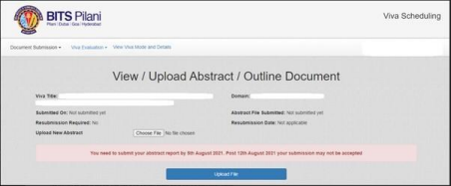

NOTE: Your report submission should be in PDF format & name of file should be your 11 Digit BITS ID (e.g. 2024ht****5) & file size should be less than 10 MB

2. Steps for Submitting Mid Semester Report

First you have to submit Midsem Plagiarism report, Click on Document Submission, Select Plagiarism Report
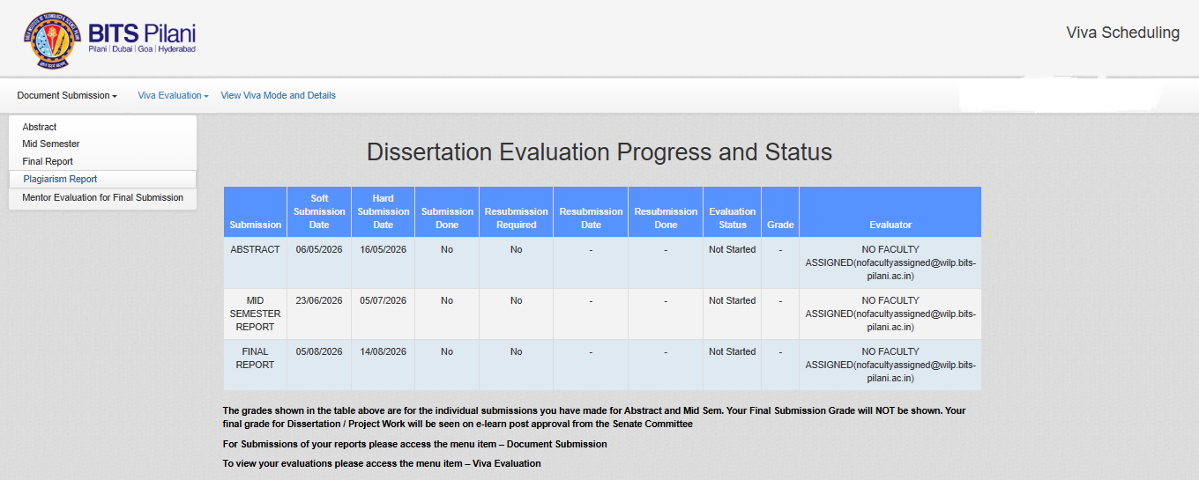

Select Submission Type as Midsem
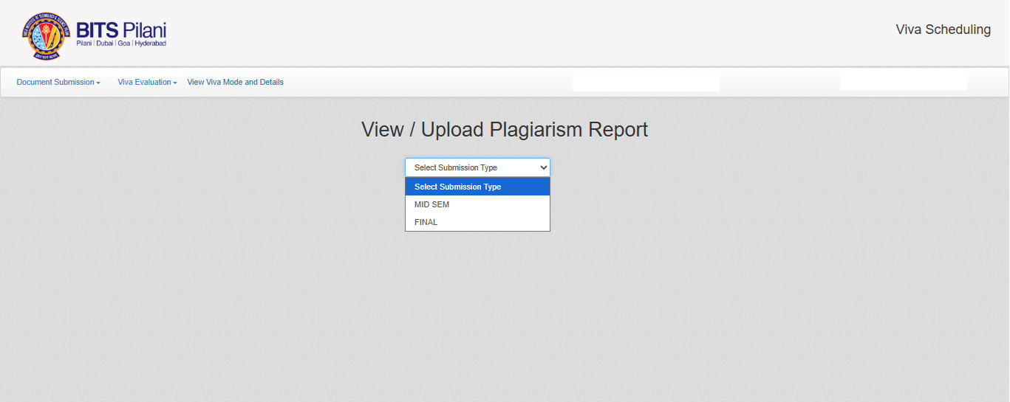
Then upload Plagiarism Similarity report, Update the correct Plagiarism Similarity Percentage & read the declaration and click on checkbox to agree the terms & condition then click on Upload File
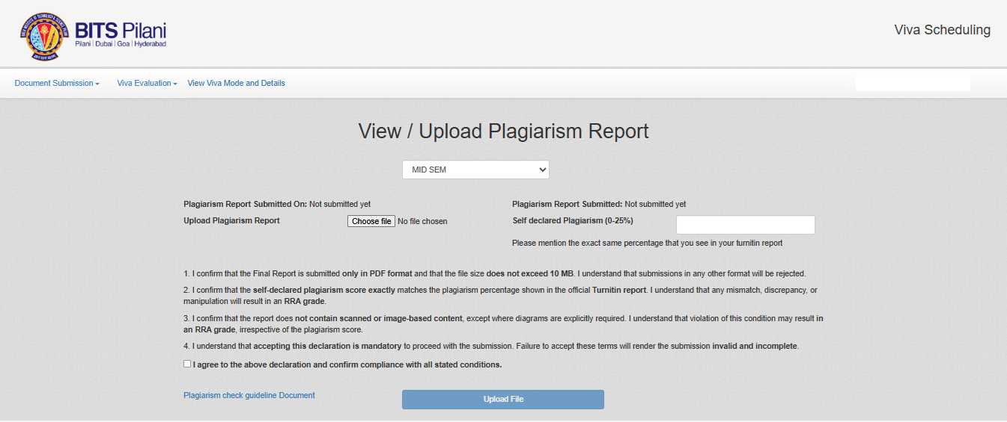

Click on the “Document Submission” link at the top left of the screen to open the dropdown menu.
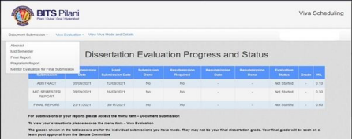

Please click on the “Mid Semester” option in the dropdown menu to view or upload the Mid Semester Report on the Viva Portal. You will then be able to see the Viva Title and the Domain details, along with the submission status.
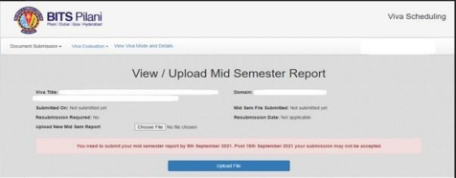

Next, click the “Choose File” option next to the “Upload New Mid Sem Report” entry to upload the Mid Semester Report on the Viva Portal. After selecting the relevant document using the “Choose File” option, click on the “Upload File” tab at the bottom to submit your document."

NOTE: Your report submission should be in PDF format & name of file should be your 11 Digit BITS ID (e.g. 2024ht****5) & file size should be less than 10 MB

3. Steps for Submitting Final Report & Final Presentation

First you have to submit Final Plagiarism report, Click on Document Submission, Select Plagiarism Report


Select Submission Type as Final


Then upload Plagiarism Similarity report, Update the correct Plagiarism Similarity Percentage & read the declaration and click on checkbox to agree the terms & condition then click on Upload File
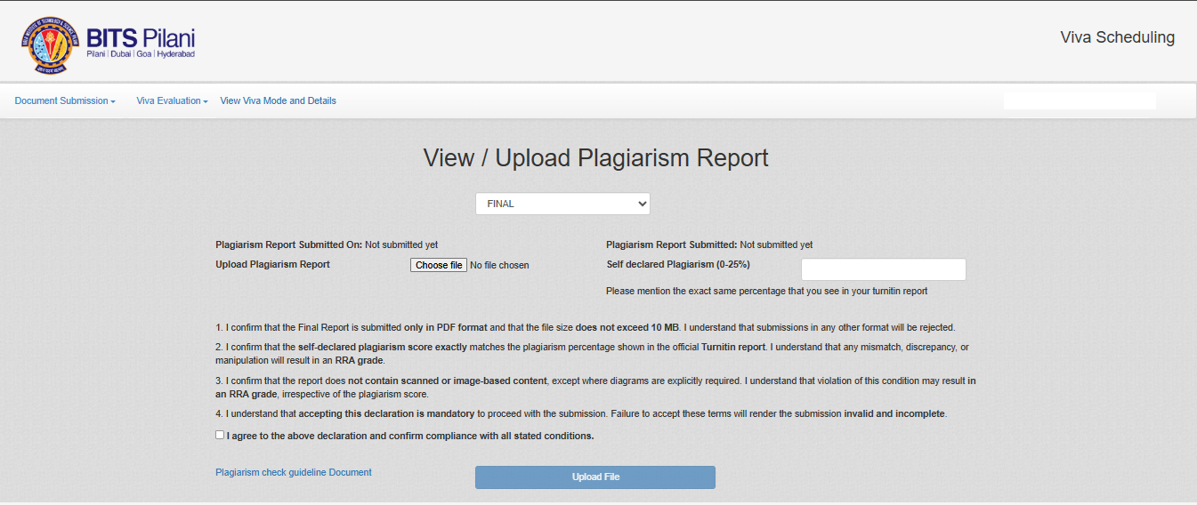

Click on the “Document Submission” link on the Top left of the screen to make the selection from the dropdown Choose the “Final Report” option to view or upload your Final Report on the Viva Portal.

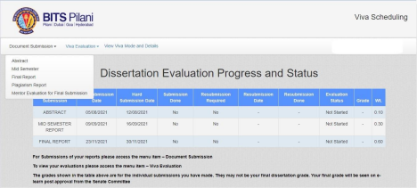

Please click on the “Final Report” option in the dropdown menu.

NOTE: -Students are required to submit both the Final Report and the Final Presentation as part of the Final Report Submission process.
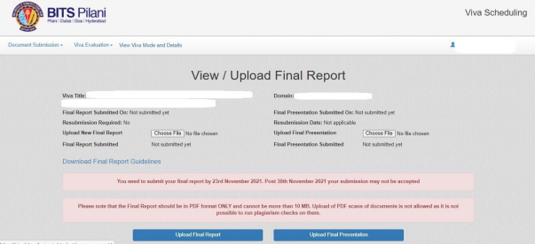
Once uploaded, click on the “Upload File” tab at the bottom to complete your submission.
NOTE: Your report submission should be in PDF format & name of file should be your 11 Digit BITS ID (e.g. 2024ht****5) & file size should be less than 10 MB

4. Step for Submitting Mentor Evaluation Form

Click "Document Submission" from the drop-down menu.
Choose “Mentor evaluation Form”

NOTE: Without Mentor Evaluation form updation in portal, faculty will not be able to evaluate/grade the reports
